Name: Dejanirra Ramirez Parker
Theme: Restaurant
Github Link: https://github.com/DejanirraMarie04/Project102

My page:
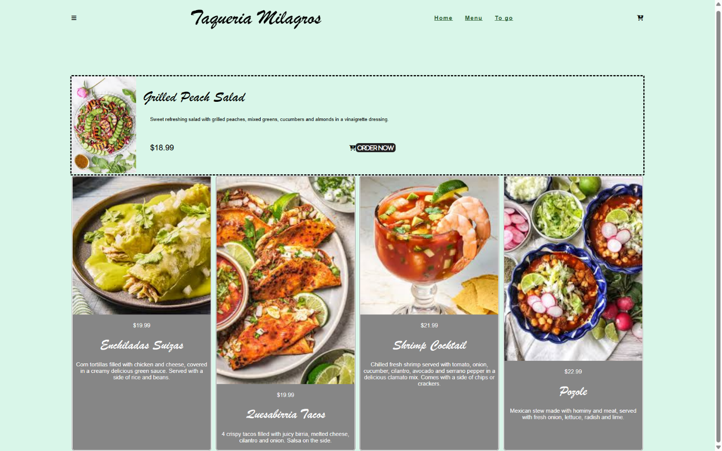
Summary:
- Added images and customized them
- Personalized description and font of each dish
- Added 2 different borders
- Added icons from font image

